Earneasy: A mobile Crowd sourcing Application

Software Project lab-3

SPL 3 Mid Report

Course Code: **Software Project Lab III (SE 801)**

**EarnEasy:**

**A Mobile Crowd Sourcing Application**

**Submitted By**

**Pritom Kumar Das**

BSSE 0919

**Supervised By**

**Dr. Md. Shariful Islam**

Professor

Institute of Information Technology

University of Dhaka

**Submission Date: 23 February, 2021**



Institute of Information Technology

University Of Dhaka

LETTER OF TRANSMITTAL

23 February, 2020

BSSE 4th Year Exam Committee

Institute of Information Technology

University of Dhaka

**Subject:** Submission of midreport of “EarnEasy: A Mobile Crowdsourcing Application”.

Dear Sir,

With due respect, I am pleased to submit the final report of Software project lab-III on “EarnEasy: A Mobile Crowdsourcing Application”. I have tried my best to deliver a good report. However, it might lack perfection. So, I therefore, hope that you would be kind enough to accept my report and oblige thereby.

Sincerely yours,

Pritom Kumar Das

BSSE 0919

8th Semester

Bachelor of Science in Software Engineering

Institute of Information Technology

University of Dhaka.

LETTER OF ENDORSEMENT

February 23, 2021

BSSE 4th Year Exam Committee

Institute of Information Technology

University of Dhaka

**Subject:** Approval of the Report

This letter is to certify that, Pritom Kumar Das, BSSE 0919, student of Institute of Information Technology, University of Dhaka, has done “EarnEasy: A Mobile Crowdsourcing Application” under my supervision. I have gone through the report. All the information mentioned in this document is true.

I wish him every success in life and hope that he will continue his effort in the future.

SPL Supervisor

**Dr. Md. Shariful Islam**

Professor

Institute of Information Technology

University of Dhaka

ACKNOWLEDGEMENT

Firstly, I would like to thank the Almighty for helping me complete the final report.

I am grateful to the Institute of Information Technology for giving such a tremendous opportunity to work on “EarnEasy: A Mobile Crowdsourcing Application”. I would like to convey my tremendous gratitude to my supervisor, Dr. Md. Shariful Islam, Professor, Institute of Information Technology, University of Dhaka, for providing me guideline about how I can prepare this report. He helped me a lot by sharing his valuable knowledge with me.

Lastly, I would like to thank my classmates. They have always been helpful and provided valuable insights from time to time.

Abstract

This document contains the software requirements and specifications, architectural design and user interface design, implementation details, testing and user manual of “EarnEasy: A Mobile Crowdsourcing Application”. Mobile crowdsourcing is an emerging technology that has enormous potential in Bangladesh. It is a term that describes crowdsourcing activities that use information collected through smartphones or other mobile devices. Companies such as Pathao, Uber, Food Panda, Sohoz are tapping into this potential to proliferate their business. However, this is only a tiny portion of what can be done using mobile crowdsourcing. With mobile crowdsourcing we can tackle the issue of lack of communication between companies and users. The goal of our project is to help the companies to get the opinion of the crowd regarding the usage, storage, purchase of their products with a simple, reliable and trustworthy method. Thanks to various useful smartphone features, including reliable GPS, excellent cameras, as well as the easy availability of smartphones; users can work on crowdsourcing tasks without almost zero difficulties. The companies can provide any task for example stock checking, user feedback of items or surveys, just-in-time checking on product situations or other simple tasks that can help with the company’s growth, prestige, popularity or profit to the users of the application. As a simple task it does not need any device other than a smartphone. The users will complete the task to earn the financial benefits that the companies offer. It will create a large body of working people and help mitigate the problem of unemployment in our country. In the era of Digital Bangladesh this project can become the gateway that connects both the companies and people. This way the companies and the users both can gain benefits through a mutual win-win situation. This document can be followed to develop a mobile crowd sourcing application.

Table Of Contents

**Chapter 1 :** INTRODUCTION 1

**1.1** PURPOSE 1

**1.2** SCOPE 2

**1.3** ASSUMPTIONS 2

**1.4** DEFINITIONS 2

1.4.1 Mobile Crowdsourcing 2

**Chapter 2 :** ELICITATION 3

**2.1** INTRODUCTION 3

**2.2** ELICITING REQUIREMENTS 3

**2.3** QUALITY FUNCTION DEPLOYMENT 3

2.3.1 Normal Requirement 4

2.3.2 Expected Requirement 4

2.3.3 Exciting Requirement 5

**2.4** USAGE SCENARIO 5

**Chapter 3 :** SCENARIO BASED MODELING 8

**3.1** USE CASE DIAGRAM 8

**Chapter 4 :** DATA-BASED MODELING 17

**4.1** DATABASE 17

4.1.1 Continuous Availability 17

4.1.2 Low Latency Rate 17

4.1.3 Easy Scalability 17

4.1.4 Ability to handle changes 18

**4.2** ER DIAGRAM 18

**Chapter 5 :** CLASS BASED MODEL 19

**5.1** ANALYSIS CLASSES 19

**5.2** CRC CARD 20

**5.3** UML 26

**Chapter 6 :** ARCHETYPE DEFINITION 27

**6.1** ARCHITECTURAL CONTEXT DIAGRAM 27

**6.2** MAPPING REQUIREMENTS TO SOFTWARE ARCHITECTURE 28

**Chapter 7 :** Testing 29

**7.1** Plan Identifier 29

**7.2** Introduction 29

**7.3** Features to be Tested 29

**7.4** Features not to be tested 29

**7.5** Approach 30

**7.6** Item Pass/Fail Criteria 30

**7.7** Test Deliverables 30

**7.8** Scheduling 30

**7.9** Planning Risks and Contingencies 30

REFERENCES 33

**List Of Figures**

Figure 1 EarnEasy Service Usage Senario 5

Figure 2 Level 0 of EarnEasy System 10

Figure 3 LEVEL 1 OF EARNEASY SYSTEM 11

Figure 4 LEVEL 1.1 OF EARNEASY SYSTEM 12

Figure 5 LEVEL 1.2 OF EARNEASY SYSTEM 13

Figure 6 LEVEL 1.3 OF EARNEASY SYSTEM 14

Figure 7 LEVEL 1.4 OF EARNEASY SYSTEM 15

Figure 8 LEVEL 1.5 OF EARNEASY SYSTEM 16

Figure 9 ER Diagram of EarnEasy System 18

Figure 10 UML Of EasrEasy System 26

Figure 11 ARCHITECTURAL CONTEXT DIAGRAM of Earneasy System 27

Figure 12 Componets Of the EarnEasy System 28

**List of Tables**

Table 1 Use Case Diagram 9

Table 2 Analysis Classes 19

Table 3 User (Company) CRC Card 20

Table 4 User(Member) CRC CARD 21

Table 5 User(Admin) CRC CARD 22

Table 6 Map CRC CARD 23

Table 7 Account CRC CARD 23

Table 8 Message CRC CARD 24

Table 9 Task CRC CARD 24

Table 10 Database CRC CARD 25

Table 11 System CRC CARD 25

Table 12 Feautres to be tested 29

Table 13 Schedule of Test Plan 30

Table 14 Test Cases Android Application (Company) 31

Table 15 Test Cases Android Application (Member) 32

# INTRODUCTION

This project is aimed to use Mobile crowdsourcing for providing financial benefits to end users and at the same time participating companies or organisations can benefit by seeking knowledge, goods, or services from a large body of people. EarnEasy is a software that will create an efficient , simple and reliable platform to connect the companies and people.

Crowdsourcing is the generalized act of outsourcing tasks, traditionally performed by employees or contractors, to a large group of the Internet population (the wise crowd) by means of an open call. With the great development of smartphones with rich built-in sensors and ratio interfaces, mixing smartphone-based mobile technologies and crowd sourcing offers vast computing resources, and leads to a new paradigm called Mobile Crowdsourcing (MCS). It involves obtaining work, information, or opinions from a large group of people who submit their data via the Internet, social media, and smartphone apps. It allows companies to farm out work to people anywhere in the country or around the world, which lets businesses tap into a vast array of skills and expertise without incurring the normal overhead costs of in-house employees. As an alternative to traditional financing options, crowdsourcing taps into the shared interest of a group, bypassing the conventional gatekeepers and intermediaries required to raise capital. So, this project will aim to create a crowdsourcing platform to connect companies with general populations.

This chapter describes the purpose, scope, assumption, and definitions of the “EarnEasy: A Mobile Crowdsourcing Application” System

## PURPOSE

The purposes of this document are:

* Identify the requirements that have to be carried out as the part of the project.
* Form the baseline for construction of the proposed system.
* Help to reduce the development effort and reveal misunderstandings, and inconsistencies early in the development cycle when these problems are easier to correct.

## SCOPE

The scope of the project is given below:

* This project will work on only android system.
* It will be developed and tested by flutter and android studio.
* The system will only work with image and text.
* The members will use smart phones to run the client side application.

## ASSUMPTIONS

The assumptions of the project are:

* The underlying network is completely reliable.
* User will have reliable internet and GPS connection.

## DEFINITIONS

This report uses the following terminologies in its description.

### Mobile Crowdsourcing

Crowdsourcing is a business model or function that relies on a large group of users as third parties for outsourcing certain tasks. Mobile crowdsourcing is using smartphones as the medium of crowdsourcing strategies . The popular use of the internet makes communication and coordination progressively cheap , tasks that would have been impossible to communicate and coordinate before have become extremely easy to set up and coordinate.[2][3] Crowdsourcing can add significant value to a product or service, and can also generate valuable connections between the users and the company.[4] Crowdsourcing is the practice of engaging a ‘crowd’ or group for a common goal often innovation, problem solving, or efficiency. Crowdsourcing can take place on many different levels and across various industries.[5]

# ELICITATION

## INTRODUCTION

Requirements Elicitation is a part of requirements engineering that is the practice of gathering requirements from the users, customers and other stakeholders. Many difficulties were faced, like understanding the problems, making questions for the stakeholders, limited communication with the stakeholders due to a short amount of time and volatility. Though it is not easy to gather requirements within a very short time, these problems have been surpassed in an organized and systematic manner.

## ELICITING REQUIREMENTS

The main task of this phase is to combine the elements of problem solving, elaboration, negotiation and specification. The collaborative working approach of the stakeholders is required to elicit the requirements. The following tasks were done for eliciting requirements-

* Quality Function Deployment
* Usage Scenarios
* Elicitation of work products

## QUALITY FUNCTION DEPLOYMENT

Quality Function Deployment (QFD) is a structured approach to defining customer needs or requirements and translating them into specific plans. It turns subjective quality criteria into objective ones which can be used to design and manufacture the products. This methodology concentrates on customer satisfaction from the software engineering process. The following requirements are identified by QFD-

### Normal Requirement

The normal requirements are generally the objectives and goals that are stated for a product or system during meetings with the user. The presence of these requirements fulfills users’ satisfaction. These are the normal requirements for the project.

* Error free easy accessible system
* User-Friendly Interface
* Android application
* Effective System
* Separate android application for companies.
* Accessible via the Internet.
* Allow valid users to login and logout.
* Restrict access to functionality of the system based upon user roles
* Allow administrators of the system to change provided information and configure parameters of the system
* Allow valid users that log in to use exciting features of application.
* Allow Administrators to delete , modify, add or update any information regarding tasks.
* This application can be used by any android device with connection to internet.
* A dedicated server have to run all the time to help users get information.
* Maintain proper security for all the data.
* Maintain a database of all users and information.
* Allows user option to modify profile or not.
* Allows user option to change language.
* Allows user to contact with admin through email if needed
* Fast loading application.
* Allow valid users assign/find tasks.
* Sort tasks based on money/distance.

### Expected Requirement

These requirements are intrinsic to the product or system and may be so elementary that the customer does not explicitly state them. Their absence will be a cause for significant dissatisfaction. Below the expected requirements for our project are briefly described.

* Payment system integration
* Error-free software
* Map facilities
* Super Admin monitors all activities
* Provide Search Facilities
* No ambiguous feature
* Data backup
* Sending notification to users if necessary.

### Exciting Requirement

These requirements are for features that go beyond the customer's expectations and prove to be very satisfying when present

* Work scheduling based on user merit.
* Showing tasks based on zoom level.
* The user interface should provide appropriate error messages for invalid input or show message if search results are not found.

## USAGE SCENARIO

EarnEasy is a mobile crowd sourcing application. This project will explore the huge untapped potential of mobile crowdsourcing in the context of our country. Our objective is to use mobile crowdsourcing to create an application that connects both the users and the companies. We want to create a workable, sustainable and maintainable crowdsourcing platform to create opportunities for both individuals and companies alike to use crowd engine.

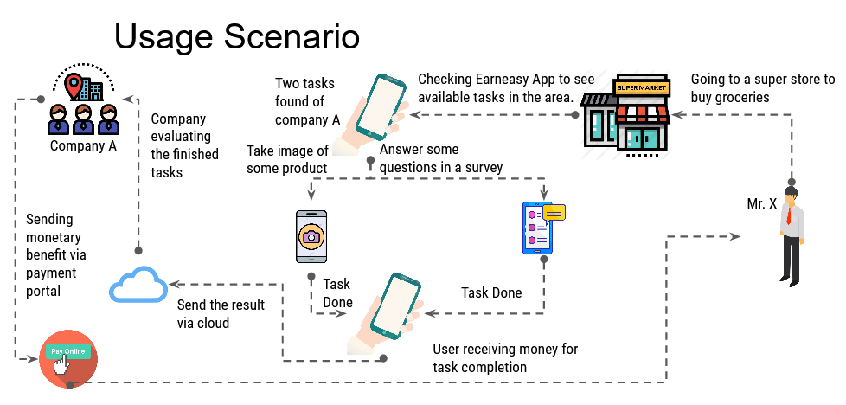

Figure 1 EarnEasy Service Usage Senario

Imagine a simple situation, Mr. X went to a grocery shop to buy some groceries for his family. He opened the EarnEasy app to check the tasks available in the area. He can accept tasks that require him to take some pictures of a particular product or talk to the shop employee about its price or other qualities. After doing some tasks he can upload the photos to the task provider via EarnEasy or answer a simple survey to best describe his experience. This way Mr. X earns some money in the midst of doing groceries. This is just one of the uses of mobile crowdsourcing. As the use of smartphones is becoming more and more popular, the practical use of mobile crowdsourcing becomes more apparent.

EarnEasy will connect the companies and the users. The companies can provide tasks or surveys with adequate payment, work description and location for the task. Through the app the users can search for the available tasks in any area or near their location. The users will need to get to the designated area to accept and start a task. The user location can be traced by using the GPS of the smart phone. Tasks will be very simple like taking some pictures of some products or completing a survey and answering some questionnaires. After completing the tasks, the user can send the necessary images via the mobile app. It will have certain time limit. The companies then can compare the documents with their requirements. If okay, the companies can send the money through the payment service of the application. Otherwise, they can give further instructions. The members can receive money through the payment portal and can send complaint in case of any delay or miscommunication. To maximize data connectivity, we will use Firestore servers. We will record all transactions to prevent any miscommunications. For better location service we will use Google Maps.API. Many services will be provided to the users of the application. Notification will be sent in case of any task, payment or account issues. There will be two major types of service based on the type of the user.

**Company Features**

The registered companies will be verified before they can use EarnEasy services. Companies that use our app will be entitled to many services. Such as -

**Privilege of issuing tasks -** Companies can issue any task that they want. They can issue the task multiple times in multiple places. They can also choose to restrict the tasks according to the level of members.

**Count members in a given area -** The companies can not see the location of an individual member but can see the number of members in a given area.

**Task rights -** Companies retain the rights to change, stop, delete or invalidate any task that they have issued.

**Rate Member Performance -** They can rate the member based on their task completion.

**Member Features**

Normal users or members will be entitled to many services. Such as -

**Accept any task -** Members can accept any task according to their choice.

**Sort tasks -** Members can sort tasks according to payment, area, difficulty, distance etc.

**Anonymity -** Members are anonymous to the companies.  The companies can only see the level and rating of the members.  Their personal information will be hidden.

**Rate task -** The users can also rate the task after completing it.

# SCENARIO BASED MODELING

Scenario based modelling is an inexpensive rapid prototyping technique. This method is effective when systems are being built with the requirements vaguely known at the outset. Users are involved right from the start, to build prototypes evolving towards the final product. The users are also involved with the testing of the prototypes which is essential for the validation of requirements and help the users to gain an initial experience of the final system during the development itself. This method involves techniques which are applied by one or more professionals working alongside users who are expected to provide and specify their requirements at the beginning as well as evaluate and approve the system upon completion. The user (in a passive capacity) and the designer/builder (an active partner) cooperate to reach a working model where the means of communications are by the examination of preliminary models such as the initial narratives, paper models and graphical representations built to represent the final system functions.

This chapter describes Scenario Based Modeling of the EarnEasy: A Mobile Crowdsourcing Application system.

## USE CASE DIAGRAM

A use case diagram is a graphic depiction of the interactions among the elements of a system. The purposes of use case diagrams are:

* Gathering requirements of a system.
* Getting an outside view of a system.
* Identifying external and internal factors influencing the system.
* Showing the interactions among actors.

The first step in writing a use case is to define the set of actors that will be involved in the story. Actors are of two types. They are:

* Primary Actors: Primary actors are the actors using the system to achieve a goal. They both consume data and produce information.
* Secondary Actors: Secondary actors are the actors that the system needs assistance from to achieve the primary actor’s goal. They either consume data or produce information.

Once actors have been identified, use cases can be developed.

Table 1 Use Case Diagram

|  |  |  |  |
| --- | --- | --- | --- |
| Level 0 | Level 1 | Level 2 | :Level 3 |
| EarnEasy System | Account Management | Sign up |  |
| Log out |  |
| Log in |  |
| Update |  |
| Verification |  |
| Delete |  |
| User Management | Company | Authenticate |
| Fill up description |
| Add tasks |
| Create/Provide/Modify work |
| Rate member’s work |
| Verify result |
| Member | GPS check |
| Start task |
| Sort tasks |
| Rate Task |
| Task complete verification |
| Send results |
| Notification Management | Task |  |
| Payment |  |
| Account |  |
| Error |  |
| Payment Management | Payment portal | Send money |
| Receive money |
| Complaint |  |
| Search | Search tasks |  |
| Search member count |  |

**Level 0****: EarnEasy Mobile Crowdsourcing System**

**Primary actors:** Company, Member.

**Secondary actors:** Admin, Database.

**Goal in context:** The diagram shown in figure: 2 represents the whole EarnEasy Mobile Crowdsourcing System.

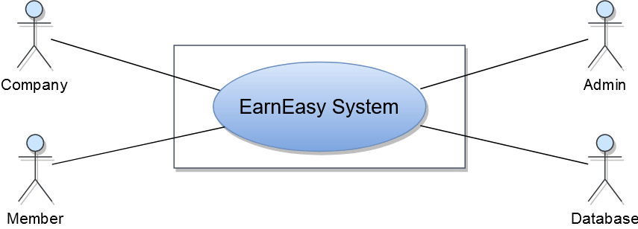

Figure 2 Level 0 of EarnEasy System

**Level 1: Modules of EarnEasy Mobile Crowdsourcing System**

**Primary actors:** Company, Admin, Member.

**Secondary actor:** Admin, Company

**Goal in context:** The diagram shown in figure: 3 shows all the modules of the EarnEasy Mobile Crowdsourcing System.

EarnEasy Mobile Crowdsourcing System consists of 5 modules. They are:

Level 1.1: Account Management

Level 1.2: User Management

Level 1.3: Notification Management

Level 1.4: Payment Management

Level 1.5: Search

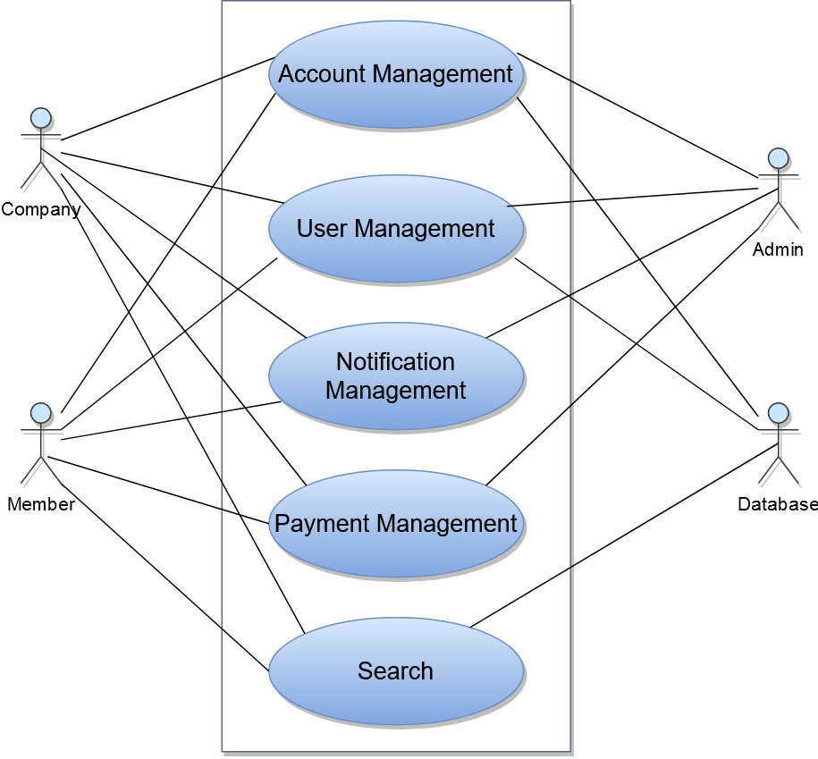

Figure 3 LEVEL 1 OF EARNEASY SYSTEM

**Level 1.1:** **Account Management**

**Primary actor:** Company, Member.

**Secondary actors:** Admin, Database.

**Goal in context:** The diagram shown in figure: 4 refers to the details of the Account Management module oflevel 1.

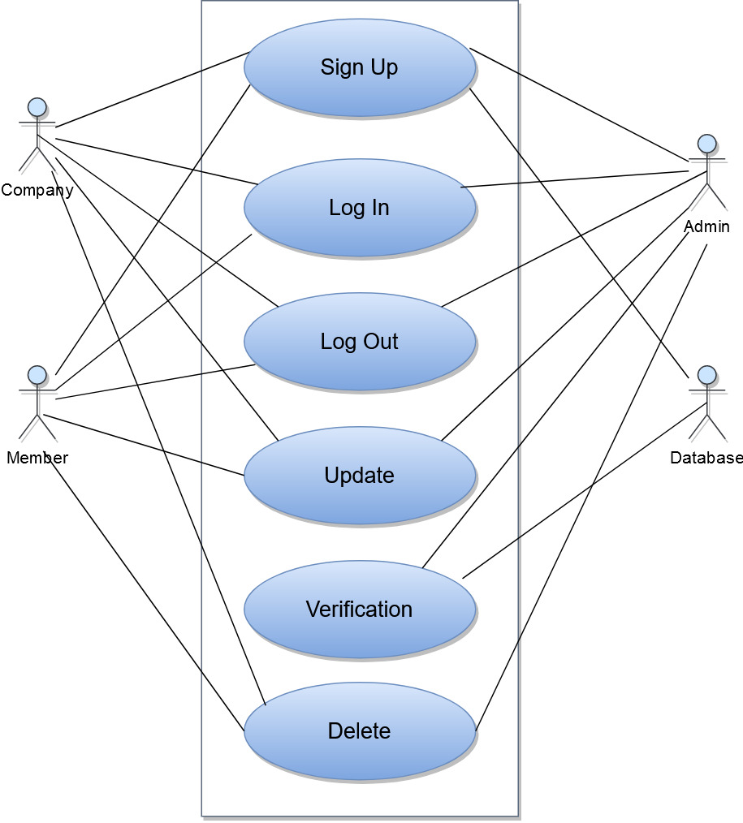

Figure 4 LEVEL 1.1 OF EARNEASY SYSTEM

**Actions and Replies**

A1: User want to sign up/log in/ log out of system.

R1: The admin and database stores the values and provides verification.

A2: User wants to update/delete/change their profile.

R2: System stores those values.

**Level 1.2: User Management**

**Primary actor:** Company, Member.

**Secondary actors:** Admin, Database.

**Goal in context:** The diagram shown in figure: 5 refers to the details of the User Management module oflevel 1.

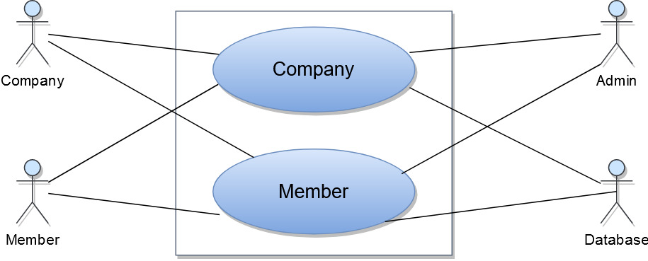

Figure 5 LEVEL 1.2 OF EARNEASY SYSTEM

**Actions and Replies**

A1: Company wants to create task that they need.

R1: The admin authenticates the company and the system stores the necessary data.

A2: Company wants to see the results send by the members.

R2: System sends the result of the particular task created by the company.

A3: The members wants to receive/accept tasks

R3: The system checks members location via GPS and provides the necessary information.

A4: The member completes the task.

R4: System verify the work and send it to the company.

A5: Member want to sort the tasks by distance/payment/title.

R5: System sort the available tasks.

**Level 1.3: Notification Management**

**Primary actor:** Company, Admin, Member.

**Secondary actors:** Company, Admin, Member, Database.

**Goal in context:** The diagram shown in figure: 6 refers to the details of the Notification Management module oflevel 1.

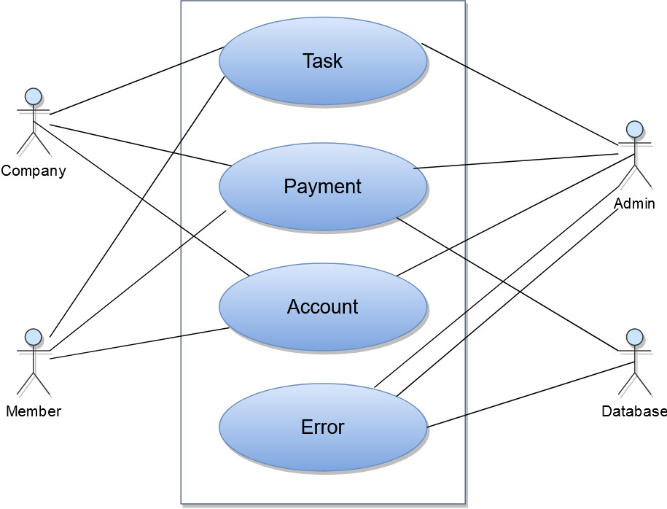

Figure 6 LEVEL 1.3 OF EARNEASY SYSTEM

**Actions and Replies**

A1: User wants to know if the given task is finished/evaluated/complete.

R1: System sends the necessary notification message.

A2: User wants to know the payment conditions

R2: System sends the necessary notification message.

A3: User wants to know account situation.

R3: System sends the necessary notification message.

A4: User wants to know the reason for errors. (If occurs).

R4: System sends the necessary notification message.

**Level 1.4: Payment Management**

**Primary actor:** Company, Member.

**Secondary actors:** Admin.

**Goal in context:** The diagram shown in figure: 7 refers to the details of the Payment Management module oflevel 1.

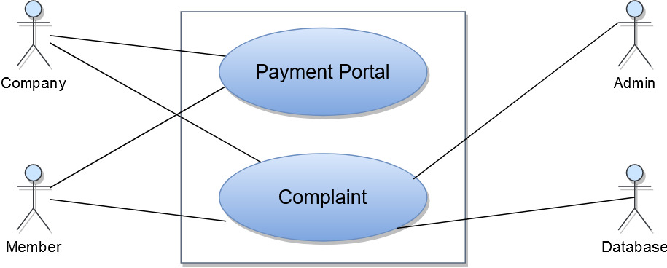

Figure 7 LEVEL 1.4 OF EARNEASY SYSTEM

**Actions and Replies**

A1: Member wants to receive payment for completed task

R1: Company sends the payment via payment portal.

A2: Company wants to send payment for completed task

R2 Member receives the payment via payment portal.

**Level 1.5: Search**

**Primary actor:** Company, Member.

**Secondary actors:** Database.

**Goal in context:** The diagram shown in figure: 8 refers to the details of the Search module oflevel 1.

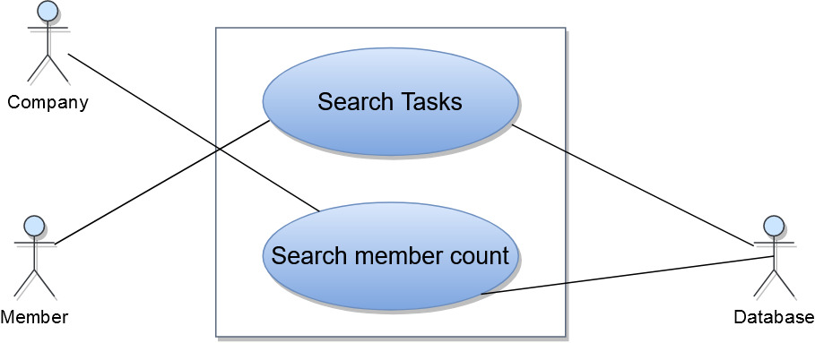

Figure 8 LEVEL 1.5 OF EARNEASY SYSTEM

**Actions and Replies**

A1: Member wants to search for tasks in a given area.

R1: System performs the search according to mobile zoom level.

A2: Company wants to know the number of members in a given area.

R2: System sends the result according to mobile zoom level.

# DATA-BASED MODELING

This chapter presents ER diagram and schema tables of the EarnEasy: A Mobile Crowdsourcing Application System.

## DATABASE

We will use firestore nosql cloud database as our data storing option. NoSQL or the so-called Not-Only SQL database stores the unstructured data in JSON format and provides a unique data storage and access mechanism that is quite different from the tabular relations in RDBMS. These unstructured databases are widely known for their non-relational and schema less data model, improved performance and scalability factors which are always an issue with relational database systems. The NoSQL databases are basically developed to meet the requirements of the modern cloud-based decentralized apps and are a good solution as compared to the relational databases in many ways.

We have decided to use this for the following reasons-

### Continuous Availability

The various relational databases may show up modern to high availability for the data transactions while this is much better with the NoSQL databases which excellently show up continuous availability to cope up with different sorts of data transactions at any point of time and in difficult situations.

### Low Latency Rate

It is easy and less time consuming to derive data from the unstructured data models in the Not-Only SQL databases. Hence, response times with these databases are fast enough and can handle the most intense operations for the applications.

### Easy Scalability

With NoSQL, it’s easy to scale database for current and future requirements. These databases can easily handle data partitioning across multiple servers to meet the increasing data storage requirements. It’s quite affordable to scale a NoSQL database in which inexpensive hardware or servers can be utilized for the purpose as compared to the relational databases which require expensive hardware solutions to meet up the scalability issues arising out of growing needs.

### Ability to handle changes

The schema-less structure of the NoSQL databases helps it cope up easily with the changes coming with time. There is a universal index provided for structure, values and text found in the data and hence, it’s easy for the organizations to cope with the changes immediately using this information.

## ER DIAGRAM

Although we are using noSql database we still need to know the relationship between the data entities. Figure 14 shows ER diagram of the EarnEasy: A Mobile Crowdsourcing Application System.

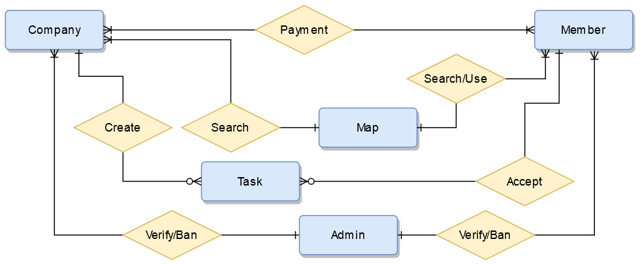

Figure 9 ER Diagram of EarnEasy System

# CLASS BASED MODEL

This chapter describes the class based modeling of the EarnEasy: A Mobile Crowdsourcing Application System.

## ANALYSIS CLASSES

After identifying nouns from scenario, I have filtered nouns belonging to solution domain using General Classification (External entities, Things, Events, Roles, Organizational units, Places, and Structures). Nouns selected as potential class were filtered using Selection Criteria (Retained information, Needed services, Multiple attributes, Common attributes, Common operations, and Essential requirements). After performing analysis on potential classes, I have found the following analysis classes:

Table 2 Analysis Classes

|  |  |  |  |
| --- | --- | --- | --- |
| Serial No | Class name | Attributes | Methods |
| 1 | User (Company) | Task, Account | addTask(), createAccount() |
| 2 | User (Member) | Task, Account | startTask(), createAccount() |
| 3 | Admin | Authenticate, | verifyAccount() |
| 4 | Map | Location | showTasks(), searchMembers() |
| 5 | Account | AccountType, | showAccount() |
| 6 | Message | Message body, type | showMessage() |
| 7 | Task | taskType, description, isRequired | showTask(), changeTaskType() |
| 8 | Database | Store, update, retrieve | storeData(), updateData(), retriveInformation() |
| 9 | System | GeneratedQuery, Send, Retrieve | generateSearchQuery(), performRoutineCheck() |

## CRC CARD

The class cards of the analysis classes are given below:

Table 3 User (Company) CRC Card

|  |  |
| --- | --- |
| User (Company) | |
| Attribute | **Methods** |
| companyName  email  level  companyID  companyAddress  certification  writeAccess  city  zipCode  photoUrl  phoneNumber  taskCompletedList | * viewMap() * viewInformation() * viewAccount() * updateAccount() * search() * addTask() * modifyTask() * sendPayment() * signIn() * signOut() * deleteAccount() |
| Responsibilities | **Collaborator** |
| Add Task | Task, Admin |
| Search member count | Database, System |
| Send payment | Member |
| Receive task Result | Database. Member |
| Create Account | Account, Admin |
| Rate member | Database, System |

Table 4 User(Member) CRC CARD

|  |  |
| --- | --- |
| User (Member) | |
| Attribute | **Methods** |
| userID  userName  email  level  address  type  writeAccess  city  occupation  zipCode  photoUrl  phoneNumber  gender  employmentStatus  taskCompletedList | * viewMap() * viewInformation() * viewAccount() * updateAccount() * search() * startTask() * completeTask() * receivePayment() * sendComplaint() * signIn() * signOut() * deleteAccount() |
| Responsibilities | **Collaborator** |
| Start/Complete Task | Task, Admin, Company |
| Search tasks in an area | Database, System |
| Receive payment | Company |
| send task result | Database, System |
| Create Account | Account, Admin |
| Rate task | Database, System |

Table 5 User(Admin) CRC CARD

|  |  |
| --- | --- |
| User (Admin) | |
| Attribute | **Methods** |
| adminID  adminName  password  email  level  address  type  writeAccess  photoUrl  phoneNumber | * viewMap() * viewInformation() * viewAccount() * updateAccount() * searchUser() * banCompany() * banMember() * verifyUser() * signIn() * signOut() * deleteAccount() |
| Responsibilities | **Collaborator** |
| Verify company | Database, System |
| Search user | Database, System |
| Ban User | System, Database |
| Create Account | Account, Admin |

Table 6 Map CRC CARD

|  |  |
| --- | --- |
| Map | |
| Attribute | **Methods** |
| Location ID  Destination  Latitude  Longitude  Area | * showMap() * showTaskLocation() * viewLocation(latlong) * searchTasks() * viewUserlocation() * changeZoomLevel() |
| Responsibilities | **Collaborator** |
| Show map with task location | Database, System |
| Search task location | Database, System |
| Change zoom level | System |
| View user location | System |

Table 7 Account CRC CARD

|  |  |
| --- | --- |
| Account | |
| Attribute | **Methods** |
| ID  Name  Address  Type  writePermission | * createAccount() * update Account() * delete Account() * checkPermission() |
| Responsibilities | **Collaborator** |
| Create/Update/delete Account | Database |
| Check User permission | Database |

Table 8 Message CRC CARD

|  |  |
| --- | --- |
| Message | |
| Attribute | **Methods** |
| MessageID  Description  ErrorMessage | * showMessage() * sendMessage() * notify() |
| Responsibilities | **Collaborator** |
| Notify user | Database, System |
| Show message in case of any event | System |
| Send message as complaint | Member, Admin |

Table 9 Task CRC CARD

|  |  |
| --- | --- |
| Task | |
| Attribute | **Methods** |
| taskId  type  taskDescription  optionList  isCompleted  require  startTime  endTime  requiredTime  access  companyId  importantNote | * addTask() * addTaskType() * createTask() * saveCompanyId() * searchTaskById() * checkAccessLevel() * checkRequiredTime() * checkCompletionStatus() * isRequired() |
| Responsibilities | **Collaborator** |
| Check access level | System |
| Provide task time | Database, Company |
| Search task by Id | Database, System |

Table 10 Database CRC CARD

|  |  |
| --- | --- |
| Database | |
| Attribute | **Methods** |
| store  update  retrieve | * store() * update() * getInformation() * SetInforamtion() * retrieve() * viewInformation() |
| Responsibilities | **Collaborator** |
| Store Information | Admin |
| update Information | Admin |
| Retrieve information | User |
| Perform routine check | System |

Table 11 System CRC CARD

|  |  |
| --- | --- |
| System | |
| Attribute | **Methods** |
| GeneratedQuery  Send  Retrieve | * generateSearchQuery() * send() * retrieve() * showInfo() * formatInfo() * checkUserLocationByGPS() * routineDatabaseCheck() |
| Responsibilities | **Collaborator** |
| Generate search key to database query | database |
| Send information to database | admin |
| Format information to show to user | user |
| Check User Location By GPS | Member |

## UML

This is the UML class diagram of EarnEasy System.

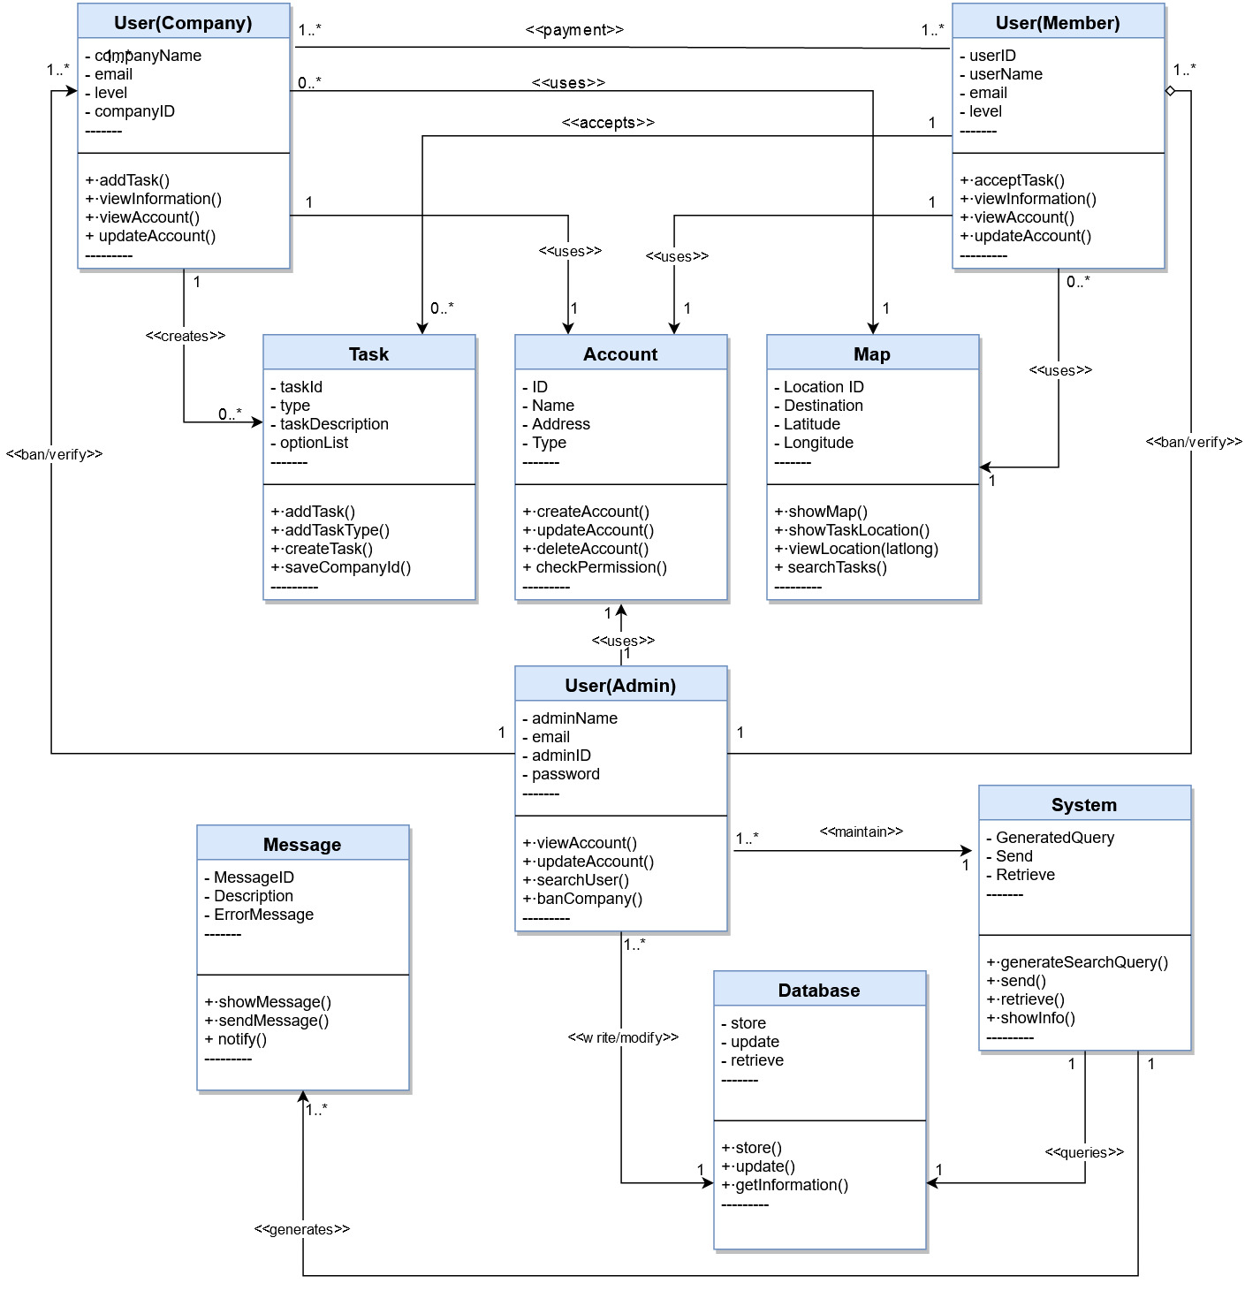

Figure 10 UML Of EasrEasy System

# ARCHETYPE DEFINITION

As architectural design begins, the software to be developed must be put into context—that is, the design should define the external entities (other systems, devices, people) that the software interacts with and the nature of the interaction. This information can generally be acquired from the requirements model and all other information gathered during requirements engineering. Once context is modeled and all external software interfaces have been described, you can identify a set of architectural archetypes.

This chapter describes architectural context diagram of the EarnEasy: A Mobile Crowdsourcing Application System.

## ARCHITECTURAL CONTEXT DIAGRAM

At the architectural design level, a software architect uses an architectural context diagram (ACD) to model the manner in which software interacts with entities external to its boundaries. systems that interoperate with the target system (the system for which an architectural design is to be developed) are represented as

● Superordinate systems

● Subordinate systems

● Peer-level systems

The following diagram represents the software in context

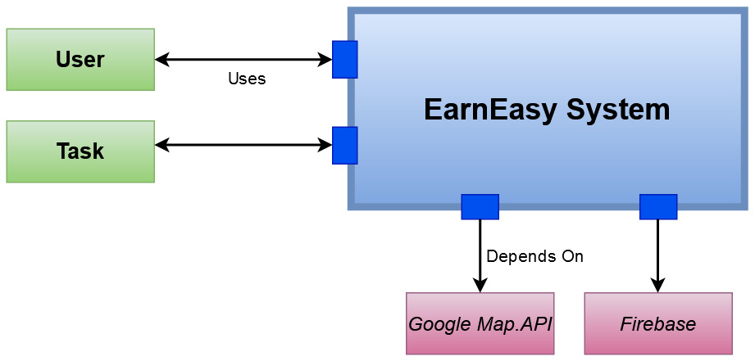

Figure 11 ARCHITECTURAL CONTEXT DIAGRAM of Earneasy System

## MAPPING REQUIREMENTS TO SOFTWARE ARCHITECTURE

As the software architecture is refined into components, the structure of the system begins to emerge. The analysis classes introduced in software requirement modeling represent entities within the application domain that must be addressed within the software architecture. Hence, the application domain is one source for the derivation and refinement of components. Another source is the infrastructure domain. The architecture must accommodate many infrastructure components that enable application components but have no business connection to the application domain.

The interfaces depicted in the architecture context diagram imply one or more specialized components that process the data that flows across the interface

For the proposed android application the following components can be introduced:

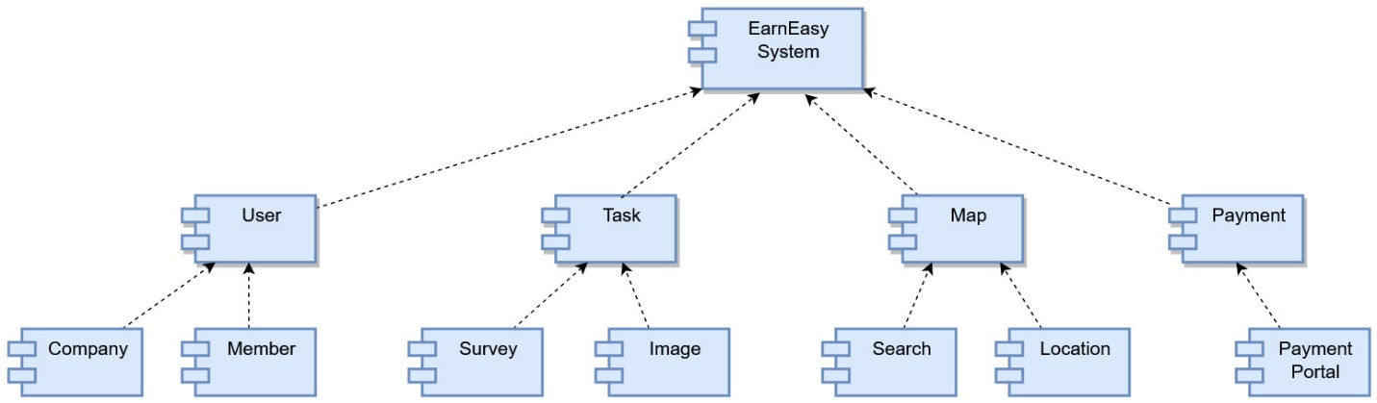

Figure 12 Componets Of the EarnEasy System

# Testing

In this project, we test the system for admin, company and member interaction. In this section, we use black box testing on the system to find any bugs or problems.

## Plan Identifier

On this project we have two android application for company and members. We use firestore noSql database. So we see various data input and output.

* Android Application (Company) Test Plan
* Android Application (Member) Test Plan

## Introduction

This test plan has been developed for “EarnEasy: A Mobile Crowdsourcing Application”. The whole system is created to test on android application with android studio and firebase firecast module for fast connectivity.

## Features to be Tested

The following features are tested:

Table 12 Feautres to be tested

|  |  |
| --- | --- |
| Application | Features |
| Android Application  (Company) | * Authentication * Payment portal * Search member count * Add/Create task with various inputs * Add/Create different types of task * Account |
| Android Application  (Member) | * Authentication * Payment portal * Search task * Accept task with various situation * Account create/remove/modify |

## Features not to be tested

All the features of the system are tested.

## Approach

I used end to end automated (integration) testing technique to test the system as a black box.

## Item Pass/Fail Criteria

If actual output of a test case does not match with expected output of the test case, the test case is considered as failed. 100% of all test cases should pass. No failed case should be crucial to the end-user’s ability to use the application.

## Test Deliverables

I will deliver test plan document, test case and test report.

## Scheduling

Scheduling is given below with different part of Quality Assurance (QA) and duration –

Table 13 Schedule of Test Plan

|  |  |
| --- | --- |
| QA | Duration |
| Test plan | 2 days |
| Testing | 3 days |

## Planning Risks and Contingencies

The following scenarios are considered as risks for the project:

● Delay in requirements engineering.

● Delay in developing.

● Modification in development technology.

Table 14 Test Cases Android Application (Company)

|  |  |  |  |  |  |  |
| --- | --- | --- | --- | --- | --- | --- |
| Android Application (Company) | | | | | | |
| Test Case ID | Scenario | Steps | Input | Expected output | Actual Output | Result |
| 1 | Authenticate using fake account | Trying to log in as company with fake credential | No input | An error message will show as company is not registered | Same as expected output | Passed |
| 2 | Not providing payment after receiving task result | Log in as company, then not paying after receiving task result | No Input | Payment not provided. Then an message showing the payment that is missed. | Same as expected output | Passed |
| 3 | Create / Add task with impossible parameter | Log in as company, then create/ add task with impossible parameter such as wrong location or negative payment or impossible deadline | Task creation parameters. | Provide meaningful parameter and an error message providing the location of the problem. | Same as expected output | Passed |
| 4 | Delete account after receiving work | Log in as company, then deleting account after receiving task result | No input | Send email with the warning printed and inform admin to take legal approach against the company | Same as expected output | Passed |

Table 15 Test Cases Android Application (Member)

|  |  |  |  |  |  |  |
| --- | --- | --- | --- | --- | --- | --- |
| Android Application (Member) | | | | | | |
| Test Case ID | Scenario | Steps | Input | Expected output | Actual Output | Result |
| 5 | Authenticate using fake account | Trying to log in as member with fake credential | No input | An error message will show to log in with valid email | Same as expected output | Passed |
| 6 | Accept task but not completing it. | Log in as member, then not completing accepted task | No input | Warning message will be send and decrease it members level | Same as expected output | Passed |
| 7 | Take on too many tasks in mutually distant areas in the same time frame | Log in as member, then accept too many tasks in mutually distant areas such as some task in Uttara and some task in Azimpur at the same time | No input | Provide warning to the user when accepting task and decrease user level if task is not completed. | Same as expected output | Passed |
| 8 | Tapping task completed option without completing task properly. | Log in as member, then tapping task is completed without finishing the required tasks. | Insufficient inputs for task | Provide warning message that task is not completed and decrease user level if task is not completed | Same as expected output | Passed |

# REFERENCES

1. A Review of Mobile Crowdsourcing Architectures and Challenges: Towards Crowd-Empowered Internet-of-Things . *Published in: IEEE Access , 07 December 2018*
2. A Survey on Security, Privacy, and Trust in Mobile Crowdsourcing . *Published in: IEEE Internet of Things Journal ( Volume: 5 , Issue: 4 , Aug. 2018 )*
3. CrowdEIM: Crowdsourcing Emergency Information Management Tasks to the Mobile Social Media Users . *Published in: 2019 ACM/IEEE Joint Conference on Digital Libraries (JCDL) . Date of Conference: 2-6 June 2019*
4. Thebault-Spieker, Terveen, & Hecht. Avoiding the South Side and the Suburbs: The Geography of Mobile Crowdsourcing Markets. *Published - Feb 28 , 2015*
5. CrowdDBS: A Crowdsourced Brightness Scaling Optimization for Display Energy Reduction in Mobile Video  *Published in: IEEE Transactions on Mobile Computing ( Volume: 17 , Issue: 11 , Nov. 1 2018 )*